**A Visual Representation of Capsule Network Computations**

Mike Ross

机器学习 | 深度学习 | 自然语言处理 | 视觉.

Currently at a Los Angeles deep learning / radiology startup (we’re hiring). See my art at [www.mikerossart.net](http://www.mikerossart.net)

目前正在洛杉矶进行深度学习/放射学方面的创业（我们正在招聘）。我的作品可以在[个人网站](http://www.mikerossart.net)查看。

Nov 15（11/15）

The new paper [Dynamic Routing Between Capsules](https://arxiv.org/abs/1710.09829) is the first published technical description of capsule networks, a neural net approach which Hinton has been [hinting at for at least five years](https://www.youtube.com/watch?v=TFIMqt0yT2I).

论文《[Dynamic Routing Between Capsules](https://arxiv.org/abs/1710.09829)》第一次公开从技术角度描述了“胶囊网络”（capsule networks），介绍了一种神经网络方法，为次，Hinton教授已经探索了至少五年。

Many discussions of the paper focus on a big picture view of how capsule networks are improvements over standard neural nets: they represent more nuanced part-whole relationships at each layer by using vectors in place of scalars. The idea is that a vector can model the “pose” of an entity, and entities with similar poses belong together. As an analogy: if you see two eyes, a mouth, and nose in a particular spacial relationship and oriented in the same direction, that’s pretty good evidence for a face with the same orientation. Standard convolutional neural nets are capable of modeling similar relationships. But they do so less compactly, with a larger number of parameters or layers (and with less ability to generalize, the paper argues).

对于这篇文章的许多评论来说，它们都是从宏观上解释了“胶囊网络”与标准神经网络相比，是如何改进的：它们通过使用矢量代替标量，更为详细地阐述了各个层之间的部分与整体的关系。思路就是，一个矢量代替可以模拟一个实体的姿态（“pose”），具有相似姿态的实体合成整体。比方说：如果你在一个特定的空间关系里看见两个眼睛，一张嘴，和一个鼻子，而它们的朝向又相同，那么就可以认定是具有相同朝向的一张脸。标准神经网络也能够模拟近似的模型关系，但是它们不够简洁，需要大量的参数和层（本文认为，泛化能力较差）。

To get a better feel for exactly what capsule networks compute, I made a diagram of the capsule-to-capsule connections in the paper. This diagram is intended for those who have read the paper and are looking for a summary reference image.

为了更好地感受“胶囊网络”（capsule networks）的计算内容，我画了一个胶囊互联的框图。本图对意图去读论文，想要一个总结参考图像的人会有帮助的。

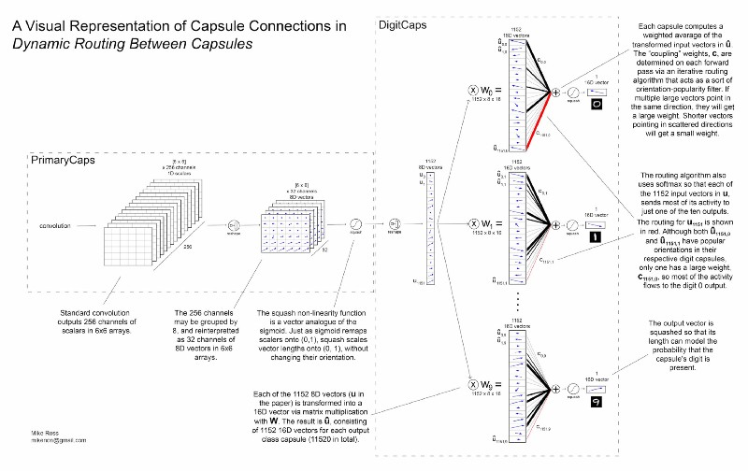

关键词：

Machine Learning，Deep Learning，Capsule Networks, Geoffrey Hinton, Google Brain